**Household Electricity**

*Reference Nelson Physics pp 197 – 200*

In Australia the electricity supplied to homes and businesses is 240 V 50 Hz AC. Power cables consist of two wires wrapped in insulation called the active and the neutral wire. These wires come from the power lines to a mains connection box containing a fuse in the active wire. From there the cable goes to a switchboard, power board or fuse box. The active wire is connected through an energy meter through to the main switch and from there to a number of circuit breakers. The neutral wire is connected to a metal bar called a neutral bar which is connected back to earth via a metal stake. The neutral wire is also earthed back at the substation.

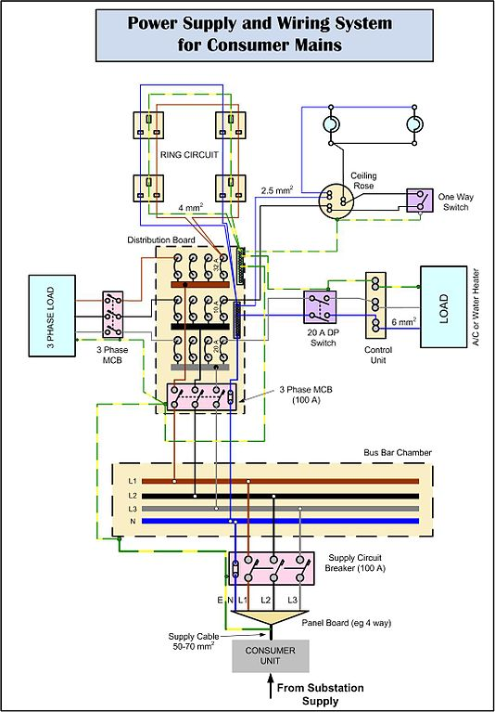

**Short Circuits**

These occur when a normal operating circuit has some of its components bypassed as the result of an abnormal connection in a circuit. A short circuit therefore is an [electrical circuit](https://en.wikipedia.org/wiki/Electrical_network) that allows a [current](https://en.wikipedia.org/wiki/Electric_current) to travel along an unintended path with no or a very low resistance. This results in an excessive amount of current flowing into the part of the circuit that is still operational and can cause damage to components and in some cases cause fires.

Common types of short circuit occur when the positive and negative terminals of a [battery](https://en.wikipedia.org/wiki/Battery_(electricity)) are connected with a low-[resistance](https://en.wikipedia.org/wiki/Electrical_resistance) [conductor](https://en.wikipedia.org/wiki/Electrical_conductor), like a [wire](https://en.wikipedia.org/wiki/Wire) and also when the insulation around wires frays or wears meaning contact is made between bare wires

**Effects Of Electric Current**

|  |  |
| --- | --- |
| P = V I and E = P t  Therefore E = V I t where V = I R we get E = I2 R t  Since the object the current is flowing through has resistance R then the energy effect of a current on the human body is determined by:   * the amount of current flowing. * how long the current flowed. * the path the current took through the body.   Electric currents flowing through the human body cause electric shock. About 50 Australians are killed by electric shock every year even in spite of safety precautions. | **C:\Users\E0432889\AppData\Local\Microsoft\Windows\Temporary Internet Files\Content.IE5\5DHE12B3\Tips-Aman-saat-memegang-listrik-Agar-Tidak-Kesetrum[1].png** |

The following table shows the effect on the body for a 0.5 s electric shock for different currents:

|  |  |
| --- | --- |
| **Current (mA)** | **Effect On The Body** |
| **1** | **felt as a “tingle”** |
| **3** | **easily felt** |
| **10** | **painful** |
| **20** | **muscles paralysed – cannot let go** |
| **50** | **severe shock** |
| **90** | **breathing is upset** |
| **150** | **difficulty in breathing** |
| **200** | **heart beat and breathing irregular with death likely** |
| **500** | **Serious burning, breathing and heart stop certain death** |

The following table shows the effect of time on the severity of a shock for a 50 mA current.

|  |  |
| --- | --- |
| **Time (s)** | **Effect On The Body** |
| **Less than 0.2** | **noticeable but not dangerous** |
| **0.2 to 4** | **significant shock possibly dangerous** |
| **More than 4** | **severe shock possible death** |

The path the current takes is also important as electric currents interfere with the nervous system and cause muscles to spasm and interfere with their normal operation. Eg chest muscles and heart muscle.

**Electrical Safety Devices**

**Earth Wires**

Many household electrical appliances have metal cases eg kettles. If the active wire inside the kettle becomes loose and touches the case then the whole kettle becomes live. Anyone touching the case will receive an electric shock as the current flows through their body. To prevent this, an earth wire is connected to the case. When the kettle is plugged in, this wire is connected via the household circuit to the earth and so the current flows through the earth wire rather than the person.

**Three Pin Plugs**

|  |  |
| --- | --- |
| C:\Users\E0432889\AppData\Local\Microsoft\Windows\Temporary Internet Files\Content.IE5\JR8ZKASH\Bs1363-non-earthed-plug[1].jpg | Three pin plugs contain:   * an active pin connected to a red or a brown wire * a neutral pin connected to a black or blue wire * An earth pn connected to a green or a yellow/green wire   The active and neutral wires connect to the circuit supplying power to an appliance. The earth wire is connected to the metal frame of an appliance so that if a fault develops it will melt the fuse or trip the circuit breaker or RCD.  Power points in homes accept three pins from a plug. The wiring is colour coded to ensure the correct pin is connected to the active, neutral or earth wire.  C:\Users\E0432889\AppData\Local\Microsoft\Windows\Temporary Internet Files\Content.IE5\JR8ZKASH\Australian_dual_switched_power_point[1].jpg |

**Fuses**

|  |  |
| --- | --- |
| C:\Users\E0432889\AppData\Local\Microsoft\Windows\Temporary Internet Files\Content.IE5\5Z2U47IU\NrcnJ[1].jpg | Since wires heat up when current passes through them, there is a limit to how much current the wires can safely carry. Household wiring is designed to prevent wires from becoming overloaded damaging circuit components and causing fires. A fuse is a special wire inserted into the circuit that melts thus stopping current flow when a specific current (usually 15 A or 32 A) passes through the wiring. |

**Circuit Breakers**

|  |  |
| --- | --- |
| A circuit breaker acts in similar manner in that when wiring is overloaded it acts to switch off the current. Unlike the fuse which must be replaced each time it melts the circuit breaker can be reset after it has been activated | C:\Users\E0432889\AppData\Local\Microsoft\Windows\Temporary Internet Files\Content.IE5\5DHE12B3\170px-Jtecul[1].jpg |

**Residual Current Devices (RCDs)**

|  |  |
| --- | --- |
| C:\Users\E0432889\AppData\Local\Microsoft\Windows\Temporary Internet Files\Content.IE5\5DHE12B3\individual-residual-current-device[1].png | RCDs or earth leakage systems detect any difference between the current in the active wire and the current in the neutral wire. In a normal circuit these should be exactly the same but moving in opposite directions. If there is a difference it is most likely due ot some current going to earth through a fault, or in the worse case, through a person. If this happens the RCD is able to switch off the current in about 20 ms. |

**Double Insulation**

|  |  |
| --- | --- |
| All wires have a layer of plastic wrapped around them. This is the first layer of insulation. A power chord or cable will have another layer of plastic insulator wrapped around the single wires. This is known as double insulation and is indicated by a double square symbol like that below:  C:\Users\E0432889\AppData\Local\Microsoft\Windows\Temporary Internet Files\Content.IE5\JR8ZKASH\100px-Double_insulation_symbol.svg[1].png | C:\Users\E0432889\AppData\Local\Microsoft\Windows\Temporary Internet Files\Content.IE5\5DHE12B3\NYM_nach_VDE_0293-308_2003-01.svg[1].png |

Some cables also have a hard plastic conduit wrapped around them which means the wires are triple insulated and even better protected.



The following table shows the effect on the body for a 0.5 s electric shock for different currents:

|  |  |
| --- | --- |
| **Current (mA)** | **Effect On The Body** |
| **1** | **felt as a “tingle”** |
| **3** | **easily felt** |
| **10** | **painful** |
| **20** | **muscles paralysed – cannot let go** |
| **50** | **severe shock** |
| **90** | **breathing is upset** |
| **150** | **difficulty in breathing** |
| **200** | **heart beat and breathing irregular with death likely** |
| **500** | **Serious burning, breathing and heart stop certain death** |

The following table shows the effect of time on the severity of a shock for a 50 mA current.

|  |  |
| --- | --- |
| **Time (s)** | **Effect On The Body** |
| **Less than 0.2** | **noticeable but not dangerous** |
| **0.2 to 4** | **significant shock possibly dangerous** |
| **More than 4** | **severe shock possible death** |

